Comp Arch 2 – Cache assignment

Q2. 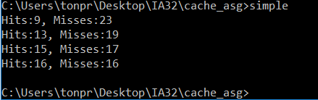

Correct answer for each question. All of them are correct and you can verify the answers by doing it by hand yourself if u want ( or run the animation online urself).

Corresponding results from animation

N =8 K =1 L=16

Miss, Hit, Hit, Miss, Miss, Miss, Miss, Miss, Hit, Hit, Miss, Hit, Miss, Miss, Miss, Miss, Miss, Hit, Miss, Miss, Miss, Miss, Miss, Miss, Miss, Miss, Hit, Miss, Miss, Hit, Miss, Hit.

Hit = 9 Misses = 23 - Correct

N = 4 K=2 L=16

Miss, Hit, Hit, Miss, Miss, Miss, Miss, Miss, Hit, Hit, Miss, Hit, Hit, Miss, Miss, Miss, Miss, Hit, Miss, Hit, Hit, Miss, Hit, Miss, Miss, Miss, Hit, Miss, Miss, Miss, Hit, Hit

Hits = 13 Miss = 19 - Correct

N = 2 K = 4 L=16

Miss, Hit, Hit, Miss, Miss, Miss, Miss, Miss, Hit, Hit, Mis, Hit, Hit, Miss, Hit, Hit, Miss, Hit, Miss, Miss, Hit, Miss, Hit, Miss, Miss, Hit, Hit, Miss, Miss, Miss, Hit, Hit

Hits = 15 Misses = 17 - Correct

N = 1 K = 8 L = 16

Miss, Hit, Hit, Miss, Miss, Miss, Miss, Miss, Hit, Hit, Miss, Hit, Hit, Miss, Hit, Hit, Miss, Hit, Miss, Hit, Hit, Miss, Hit, Miss, Miss, Hit, Hit, Miss, Miss, Miss, Hit, Hit

Hits = 16 Misses = 16 - Correct

Q3. 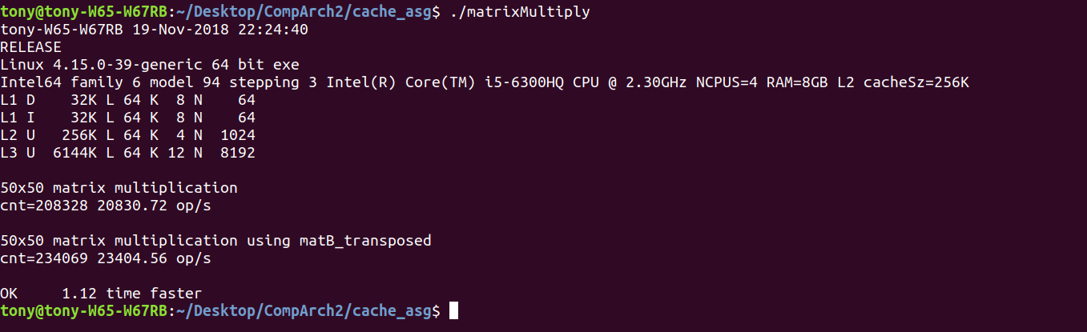

1.12 times faster apparently